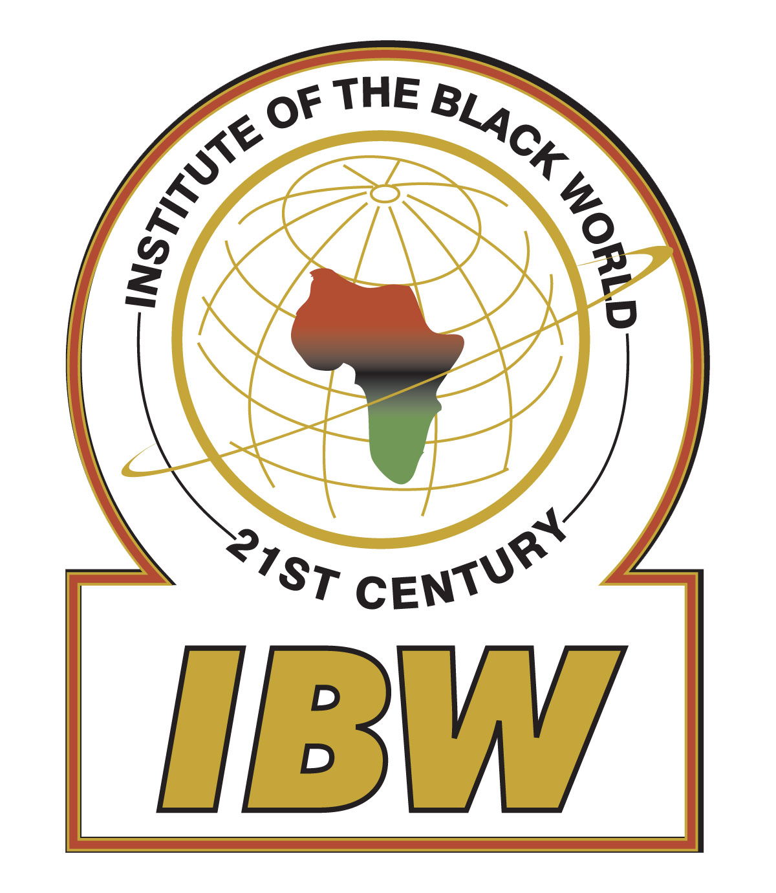
_________________________________________________________________________________________________
31-35 95th Street, East Elmhurst, NY 11369 ♦ 718.429.1415 ♦ info@ibw21.org

October 31, 2013

President Danilo Medina Sanchez,
Ave. México, Gazcue,
Distrito Nacional
Santo Domingo,
República Dominicana

Your Excellency President Medina Sanchez:

I am writing to you on behalf of the Board of Directors of the Institute of the Black World 21st Century (IBW) to express our utter indignation and deep distress at the recent Constitutional Court decision that effectively revokes citizenship to some 250,000 persons of Haitian descent born in the Dominican Republic.

This blatant violation of human rights is an insult to decent and fair-minded people across the globe and a serious setback to human rights and democracy in the Caribbean and Latin American region. We call on you to use the powers of your good office to immediately rectify this egregious situation.

We also echo the sentiments of outrage and condemnation unanimously expressed by the more than 100 participants at IBW’s recent symposium on the ‘Future of Democracy & Development in Africa and the Caribbean’, held in Washington D.C. at the historic Metropolitan AME Church on October 17 & 18th. Participating in the symposium were former President of Cape Verde Hon. Pedro Pires, Hon. Prime Minister Dr. Ralph Gonsalves of St. Vincent & the Grenadines and a wide range of prominent civic leaders, current and former ambassadors, distinguished academics and human rights advocates from across the United States.

In his keynote address to the symposium, Prime Minister Gonsalves read a letter that he had written to you on Oct. 11 in which he stated that the Court’s ruling is “unacceptable in any civilized community” and is an “affront to all established international norms and elemental humanity.”

We agree with Prime Minister Gonsalves that the ruling undermines your country’s international human rights obligations as enshrined in several international and hemispheric treaties and conventions to which the Dominican Republic is a state party.

The Institute of the Black World will join forces with other human rights groups from across the Americas to challenge this racist ruling before the Inter-American Court of Human Rights.

Mr. President, please note that IBW has a long-standing relationship of friendship and solidarity with the people of Haiti and with Dominicans of Haitian ancestry. Since the early 1990s, fact-finding and humanitarian aid delegations led by IBW have visited Haiti on several occasions. Those visits have resulted in the establishment of our permanent Haiti Support Project to provide ongoing humanitarian and development assistance to Haitian civil society organizations working in the areas of health and education. Our ongoing commitment to the welfare of the Haitian people is rock solid.

As a consequence of the court’s ruling, a quarter million Dominicans of Haitian descent of all ages today find their lives hanging in the balance having been rendered stateless by the court. As persons who are de facto stateless they do not qualify for any protections under international law, cannot travel legally outside of the Dominican Republic thus ensuring that they remain in a state of perpetual servitude and third-class status.

As Prime Minister Gonsalves said in his letter, “the highest office in the land is that of citizenship….it is an inward grace from which springs the bonds of national community in the landscape and seascape of the country of one’s birth.”

Mr. President, we trust that as a person of conscience, integrity and high principles you will move swiftly to condemn and revoke this immoral ruling. Your own citizens of Haitian descent, along with the people of the entire Americas expect nothing less.

Sincerely and Respectfully,
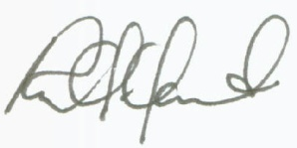
Dr. Ron Daniels,
President, Institute of the Black World 21st Century.

