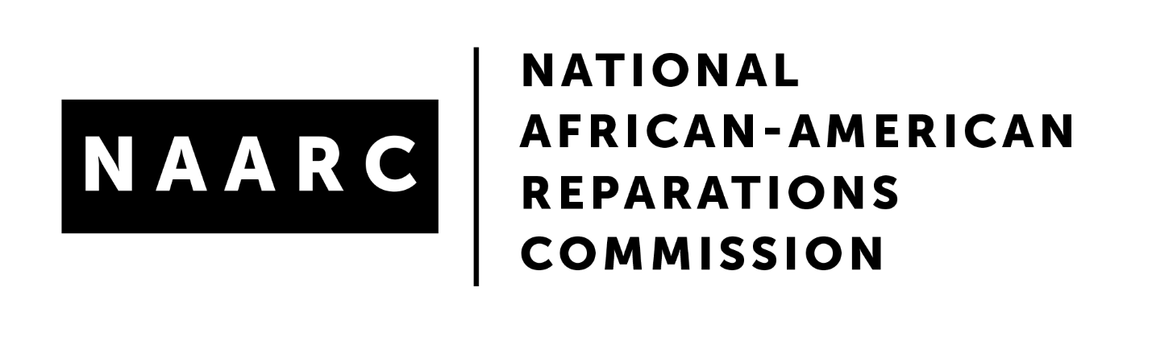

Basic Elements for Municipal Reparations Initiatives
Background: The following elements were devised by the National African American Reparations Commission as a baseline for certifying Municipal Reparations Initiatives based on the Evanston Reparatory Justice Model.
●Acknowledgement and an apology for harm, injury or crimes committed are a necessary pre-requisite to remedy/repair.
●Consistent with the principles of Restorative Justice, the party that inflicted the harm or injury, cannot define the remedy or repair. The affected party must define the remedy or repair and agree to same through negotiations
●The affected party must be trusted to control the administration of the remedy, e.g., resources or opportunities offered via an independent community institution or structure. A Community Reparations Finance Authority which can receive and administer public and private resources would meet this criteria.
●Reparations must be distinguished from regular or ordinary public policy which is intended to address current or immediate issues, problems, concerns. For example, there is near universal agreement that equity polices are excellent for addressing issues of inequality, inequities today and into the future. However, applying an equity lens on current policy does not address the accumulated harms/injury of enslavement and the derivative post-emancipation racially exclusionary policies and practices.
●Municipal reparations initiatives should be community based, stakeholder driven or sanctioned by community stakeholders through an inclusive process.
●A Community Stakeholder Authority/Commission/Task Force should be the structure where reparations proposals are developed based on an inclusive process of receiving input from the community. Reparations proposals should be presented to the City Council and/or the Mayor with the understanding that these proposals/recommendations will be adopted/enacted as long as they meet the requirements for legislation as outlined by the City Charter.
●An application process should be developed by the Community Stakeholder Authority and presented to the City Council and/or Mayor for adoption.
●Municipalities should allocate funds for consultants to advise Community Stakeholders and the city on ways to develop and implement reparatory justice initiatives.

