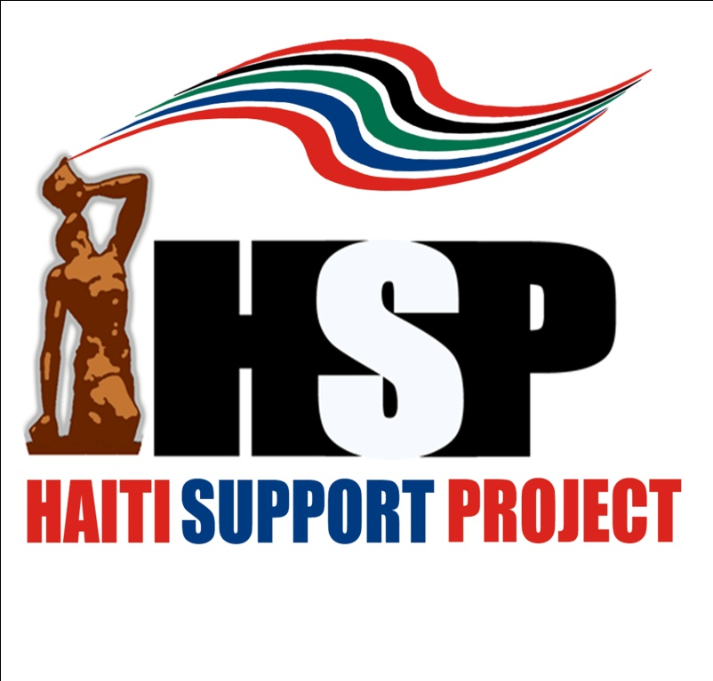
Communiqué
Pilgrimage and Assessment Delegation
October 7-11, 2010
Prepared by Dr. Ron Daniels

October 7-11, the Haiti Support Project (HSP) led its third Delegation to Haiti since the fateful earthquake of January 12th. The atmosphere was in marked contrast to HSP’s Third Annual Pilgrimage in October of 2009 when there were signs of a much brighter future for Haiti and its people. A year ago there were clear indicators that after a period of political stability, relative security and greater transparency and accountability by the government, conditions were ripe for modest economic growth and new levels of international investment. There was optimism in the air. Everything changed after January 12th. Now, with the assistance of the international community, Haiti’s fragile governmental and private institutions face the awesome challenge of lifting the people and nation out of the abyss of one of the most devastating catastrophies ever to strike a Caribbean nation.

We set the following modest goals for the Delegation:

▪ Conduct a limited assessment of recovery/reconstruction progress since previous delegations in February and May of this year.

▪ Make our annual visit to Milot in support of the Model City Initiative which seeks to transform this town into a destination for cultural-historical tourism as a foundation for people based economic development.

▪ Provide additional capacity-building contributions/grants to grassroots/community based organizations from HSP’S Haiti Relief Fund.

▪ Create opportunities for journalists in the Delegation to gather information to give continued visibility to the ongoing recovery/reconstruction process in Haiti.

Synopsis:

Our Delegation was received by U.S. Ambassador Kenneth Merten and officials of USAID at the U.S. Embassy. Ambassador Merten provided an extensive, candid and useful assessment of the complexities and challenges of the reconstruction process, including ameliorating and ultimately transforming the condition of some 1.5 million displaced persons living in tent communities. The following are among the observations and points offered by the Ambassador:

▪A Shelter Coordinator has been appointed to work with the Government and private aid agencies to devise a comprehensive plan for relocating displaced persons from tent communities to permanent shelter.

▪A considerable number of displaced persons are choosing to return to their old neighborhoods in hopes of reclaiming and rebuilding their homes.

▪The highly touted concept of decentralization will only be effective if there are economic incentives that encourage people to remain in smaller communities and towns. Otherwise, people will continue to migrate to urban centers like Port Au Prince.

▪A Korean corporation is planning to build two major industrial parks, one near Cap Haitien and another in the Central Plateau near Hinche.

▪In addition to Port Au Prince, the U.S. is concentrating resources and energy on the Northern region, an area around St. Mark and the town of Leogane which was almost totally destroyed by the earthquake.

▪Improving agriculture, health and the justice systems were identified as key priorities for the U.S. as well as establishing a unit that will systematically track the expenditure of U.S. aid dollars.

▪Florida State Representative Hazelle Rogers introduced Dean Decker and Kenneth Koch, officers of the Broward County Building Officials Association, who are eager to offer the services of the Association, free of charge, to assist the government with designing and implementing an effective building code system as part of the reconstruction.

Visit to Tent Community

The Delegation returned to the same tent community visited by the HSP Delegation in February. The community is near the National Palace in downtown Port Au Prince. The purpose of the visit was to assess conditions in the Community eight months later. We were briefed by leaders of the community after which some participants took a tour of sections of the Community. We were informed that a number of people, including some individuals who had been part of the leadership during our last visit, had moved out and returned to their neighborhoods. The leaders expressed intense anger and frustration over the disregard of their concerns by the Government and international aid agencies. They were particularly bitter about the visit of President Preval and former President Clinton whom they claim made promises that have not been kept. Other complaints included:

▪Little assistance from agencies like Oxfam and the Red Cross

▪Regular distribution of water but serious concern that some deliveries have been tainted with bacteria because residents got sick after drinking it

▪Irregular distribution of food

▪Inadequate medical supplies for the health care clinic that doctors and medical students established after the earthquake to serve the community and patients from the surrounding communities

▪No school or organized activities for children

Deterioration in discipline among the youth and increased instances of tension/conflicts in the community. Leaders gave the UN MUNISTAH high marks for responding to requests to provide security.

▪Lack of clear liaison with agencies of the Haitian Government

▪State Representative Hazelle Rogers encouraged the leaders to be more proactive in engaging the community to organize clean-up campaigns and program/activities for the children/youth.

Other than the regular water distributions and an adequate number of portable toilets (which was not in evidence during our February visit), conditions seemed to have stagnated in this particular community if not worsened. Beyond anger/frustration, there was an attitude of resignation among the leaders and within the community as life in tents under miserable conditions appears to be the new normalcy for millions of Haitian people.

Visit to the Central Plateau

The Delegation made a follow-up visit to the Central Plateau for consultation with the Peasant Movement of Papay (MPP), the largest peasant movement in Haiti. HSP provided contributions/grants to MPP from the Haiti Relief Fund during our visit in May for assistance to displaced persons who moved to Papay from Port Au Prince and for the SEEDS Project to enable farmers to purchase seeds to plant crops. The road to the Central Plateau has dramatically improved since HSP’S early delegations to Haiti in the 90s. A trip that used to take eight hours has been cut to three and a half. All along the route crews were busy at work finishing the most difficult stretches of the road. This is a very positive development.

Members of the Executive Committee of MPP conducted a comprehensive briefing outlining the history, structure and programs of the organization. We also took a tour of the education and training facility to observe some of the very innovative agricultural experiments that are being tested to improve production. A number of key points were made during the briefing:

▪There was strong criticism of the Government’s lack of priority on the agricultural sector. The Committee said their research indicates that 80% of the Ministry of Agriculture’s budget is for administration leaving only 20% for programs/projects in the field.

▪The inability to purchase seeds is a major handicap for many small farmers.

▪Women members of the Committee identified insufficient health care facilities to offer pre-natal and pediatric care as a major problem.

HSP Initiatives:

▪ We made our annual Pilgrimage to Milot to tour the Citadel and discuss aspects of the Model City Initiative with the Local Development Committee of Milot and local officials. School supplies for some 2,000 children had already been purchased from a contribution/grant from HSP as well as scholarships for one hundred students. We were received by the Local Development Committee and local officials and had an opportunity to interact with some of the students who received scholarships. The students made special presentations to members of the Delegation as a very moving expression of appreciation. Dr. Julianne Malveaux, President of Bennett College for Women, advised the Local Development Committee that students from the college are prepared to organize service brigades to do work in Milot in support of the Model City Initiative.

▪ The Delegation also visited the first Oasis Institute Camp for orphaned children. The goal of the Oasis Institute which was conceived by Lionel Pressoir, HSP’s principal partner and liaison on the ground in Haiti, is to eventually identify 800-1,000 children orphaned bythe earthquake to be relocated to safe/secure camps where they will receive counseling and a quality education. The ultimate goal is to build a permanent campus to house the children. A major priority of Oasis Institute is to develop a quality program with wrap-around services so as many orphans as possible can remain in the country to be educated to become engaged citizens and leaders of the new Haiti. Though a large tract of land was made available for the Institute by the University of Quisqueya which would have accommodated about eight hundred children, Lionel Pressoir was unable to secure support from MINISTAH or the Government to properly grade the land. Therefore, the initial plan was scaled back to create two camps with 40 children each, one for girls and one for boys. We visited the girls’ camp and were very impressed with the organization of the facility and outline of the daily schedule of program activities. It was noted, however, that many of the young people did not have school supplies.

▪ An HSP team also visited an educational campus being built by Royal Caribbean International near Labadee for 300 elementary level students. The campus was still under construction but by all indications will be a very beautiful facility that will offer an outstanding education.

Contributions from the Haiti Relief Fund

HSP made three additional contributions/grants totaling $35,000 during this visit:

▪ An additional contribution/grant of $5,000 to the SEEDS Project of MPP to enable farmers to purchase seeds to plant crops.

▪ A contribution of $20,000 to the Local Development Committee of Milot to initiate a cash-for-work jobs training program for youth/young people. Working in collaboration with ISPAN, the agency responsible for Haiti’s historical sites, the jobs program will train youth/young people to be employed as guides and related occupations in the tourism industry in the region.

▪ A contribution of $10,000 to the Mouvement d’Unite de la Communaute Par i’lntegration (MUCI) for a cash-for-work jobs training program for youth/young people. MUCI will give stipends for youth/young to provide services in the community and learn vocational skills to enhance their opportunities for employment.

Observations:

♦ Nine months after the earthquake one has an impression of incremental but grossly insufficient progress in terms of crucial reconstruction challenges, particularly relocating displaced persons from the tent communities to permanent homes. Most streets in Port Au Prince are open, commerce in the improvised market places is bustling and there is less rubble. But, the tent communities are the dominant reality as one travels throughout the city. There is a sense of inertia which threatens to make these squalid dwelling places the new norm for hundreds of thousands of people in Haiti. Moreover, without a viable decentralization plan that includes a priority on sustainable agriculture and agro-industries, the inertia is likely to lead people to vote with their feet and return to their old neighborhoods to rebuild in the same hap hazard manner that rendered Port Au Prince a disaster waiting to happen.

♦ Finally, we in HSP continue to believe that this inertia is the consequence of a lapse of leadership by the Government and to some degree the U.S. and international community. There has been a failure to engage/mobilize the Haitian people, especially those languishing in the tent communities, to participate in the reconstruction process in a meaningful manner. This is potentially a huge lost opportunity to bridge social and political divides to build the new Haiti. Though inertia has set in, it may still not be too late to correct this glaring omission in the reconstruction process. Therefore, HSP will continue to advocate for a comprehensive plan to tap the remarkable resiliency and energy of the Haitian people as a dynamic element in the reconstruction process.

Policy Advocacy:

♦ During the Briefing with Ambassador Merten, he noted that a focus on agriculture is a major priority for the U.S. We not only concur with this priority, we believe the U.S. should aggressively act to undo policies which previously undermined Haitian agriculture in favor of American agri-business interests. Accordingly, HSP reiterates the need to incentivize agricultural development in much the same way manufacturing has been incentivized through the passage of a series of HOPE Acts by the U.S. Congress. We believe there is an inter-relationship between the goal of decentralization and a robust agricultural sector. Therefore, HSP continues to advocate that Congress pass legislation with measures that would incubate the agricultural sector through 2020.

♦ A large scale New Deal WPA type public works/jobs program is the other policy initiative HSP has consistently proposed/advocated. While the cash-for-work programs/projects funded by the U.S. and other international agencies are commendable, they need to be greatly expanded and institutionalized as a strategy for combating the high level of unemployment, particularly among Haiti’s youth/young people.

HSP Action Items:

♦ Given the priority of the Cap Haitien/Milot region in the reconstruction plan, in conjunction Destination Haiti and Joe Beasley Foundations, HSP will devise a Five Year Development Plan for the Model City Initiative in Milot. The plan will be based on the vision of the town as a destination for cultural-historical tourism and outline opportunities for investment in key links in the tourism chain.

♦ HSP is eager to showcase the capabilities and services of the south Florida based Broward Building Officials Association, experts in building codes who have offered to assist the Government of Haiti pro bono. Accordingly, we have agreed to initiate a home rehabilitation and beautification project in Milot as part of the Model City Initiative, utilizing the services and resources of Association. This initiative will serve as a Pilot Project demonstrating the capacity of the Association.

♦ Destination Haiti Foundation and the Local Development Committee of Milot will explore possible projects to engage a student brigade from Bennett College for Women in support of the Model City Initiative.

♦ As a follow-up to our visit to the Royal Caribbean school and education campus at Labadee, HSP and Destination Haiti Foundation will explore the feasibility of being the principal partners for Royal Caribbean in constructing a similar facility in Milot as part of the Model City Initiative.

♦ HSP will contact the Federation of Southern Farm Cooperatives to initiate a process of connecting Black farmers in the U.S. with the Peasant Movement of Papay and other peasant organizations with the objective of providing technical support and material assistance to farmers in Haiti.

♦The Joe Beasley Foundation will contact Project Med-Share and other agencies to assess the possibilities of securing a consistent flow of medical supplies to enable the MPP to establish a limited number of community health centers in the Central Plateau with an emphasis on the needs of women and children.

♦ HSP will immediately raise funds to ensure that the eighty orphaned children in the first Oasis Institute Camps have school supplies and other basic necessities.

♦ Raising resources to achieve the vision/mission of the Oasis Institute will be the major priority of HSP’s Haiti Relief Fund in 2011.

♦ HSP invites people of African descent in the U.S. and the Caribbean and friends of Haiti everywhere to join the mobilization to make Pilgrimage of Hope: A Cruise for Conscious People Committed to Rebuild Haiti a reality. This extraordinary initiative seeks to mobilize 2,300 to travel to Haiti October 3-10, 2011 aboard Royal Caribbean’s Majesty of the Seas on a humanitarian, cultural enrichment and economic empowerment mission. Though the journey is nearly a year away, interested parties must register with their deposits before December 1, 2010 in order to secure the ship.

The Haiti Support Project: website - www.ibw21.org Email: Info@ibw21.org
Toll Free Information Line: 888.774.2921

Haiti Support Project Pilgrimage and Assessment Delegation

▪ Honorable Hazelle P. Rogers, State Representative, Lauderhill, FL
▪ Dr. Julianne Malveaux, President, Bennett College for Women, Greensboro, NC
▪ Victoria Rowell, Actress, humanitarian, Los Angeles
▪ Erin D. Hackney, Vice-President, Joe Beasley Foundation, Atlanta
▪ Dean Decker, Treasurer/Director, Broward County Building Officials Association, Miami
▪ Kenneth Koch, Director, Broward County Building Officials Association, Miami
▪ Tatiana Z. Walker, Student, Bennett College for Women, Greensboro, NC
▪ Natasha Lewis, Student, York College City University of New York, Jamaica, New York
▪ Herb Boyd, Staff Writer, New York Amsterdam News, Reporter, Free Speech T.V.
▪ Eddie Harris, Award winning filmmaker, Free Speech T.V., New York
▪ Richard Muhammad, Editor-in-Chief, The Final Call Newspaper, Chicago
▪ Ellen Ratner, News Talk Radio, Washington, D.C.
▪ Hulbert James, Board of Directors, Institute of the Black World 21st Century and Haiti Support Project Working Group, Miami
▪ Mary France-Daniels, Board of Directors, Institute of the Black World 21st Century and Haiti Support Project Working Group, New York
▪ Dr. Ron Daniels, President, Institute of the Black World 21st Century, Founder, Haiti Support Project, New York

Our thanks to Tour Haiti for once again providing suburb logistics and arrangements for our Delegation.
115 Rue Faubert – HT 6140 – Pétionville, Haïti. Tél.: [509] 2257 1926 / 2510 2223. Email : info@tourhaiti.net

